**Practical – 3**

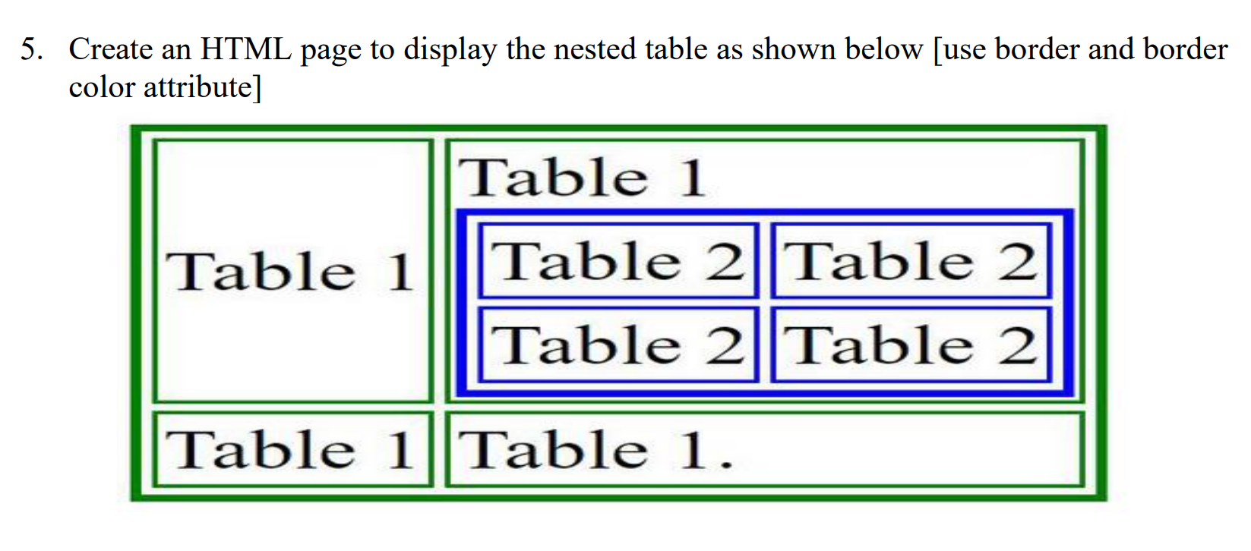

**HTML Code**

<!DOCTYPE html>

<html lang="en">

<head>

<meta charset="UTF-8">

<meta name="viewport" content="width=device-width, initial-scale=1.0">

<title>Rowspan & Colspan </title>

</head>

<body>

<center>

<table border="2" style="border-color: green;">

<tr>

<td>Table 1</td>

<td>

Table 1

<table border="2" style="border-color: blue;">

<tr>

<td>Table 2</td>

<td>Table 2</td>

</tr>

<tr>

<td>Table 2</td>

<td>Table 2</td>

</tr>

</table>

</td>

</tr>

<tr>

<td>Table 1</td>

<td>Table 1</td>

</tr>

</table> </center></body>

</html>

**Output**

